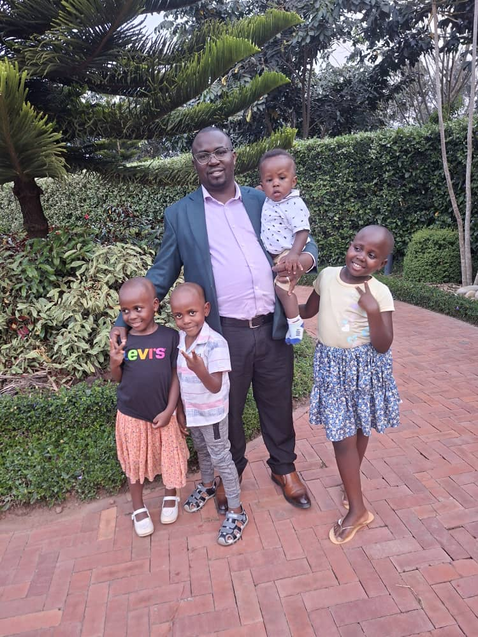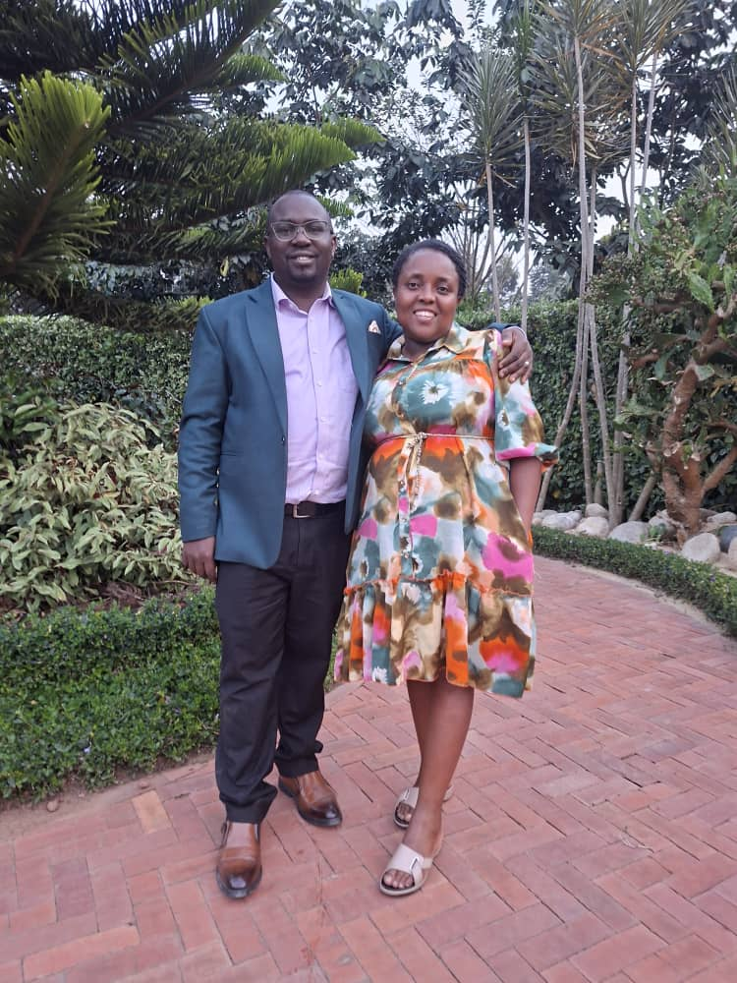
With my Children With my wife
Living God’s Plan Through Natural Family Planning
By Dr. Alex Rutebwa Rubarema
Pro-lifer from Mbarara
My journey with the Uganda Martyrs Pro-Life Apostolate began in 2012, when I was a student at Makerere University. Inspired by the Church’s call to defend human life and uphold the dignity of every person, I gradually came to appreciate Natural Family Planning (NFP) as a beautiful way of living God’s plan for marriage and responsible parenthood.
When I married my wife in September 2016, we made a deliberate decision to practice NFP. Since then, God has blessed our marriage with four beautiful children—two girls and two boys. Through NFP, we have been able to prayerfully discern when to welcome each child and to space our children responsibly.
For us, NFP has been much more than a way of planning our family. It has strengthened our marriage. It has taught us to communicate openly, to listen to one another, and to approach our fertility with mutual respect, love and responsibility. Rather than seeing fertility as something to suppress, NFP has helped us see it as a gift from God that we are called to understand and steward wisely.
Our experience has also inspired us to accompany other couples. We have had the opportunity to guide couples who were struggling with modern contraceptive methods and introduce them to NFP. Many have discovered through it a renewed sense of peace, hope and confidence in their marriages.
NFP has shown us that responsible parenthood does not have to come at the expense of faith, love or openness to life. It is a lifestyle rooted in faith, discipline, communication and love.
Our children have reminded us of the truth of Scripture: “Children are a heritage from the Lord” (Psalm 127:3). They are not accidents or obstacles, but precious gifts entrusted to us by God.
I invite couples, especially young couples, to discover the beauty of Natural Family Planning. Learn your fertility. Communicate with one another. Make decisions together. And most importantly, invite God into those decisions.

Quote for Home page
“NFP has strengthened our marriage, deepened our love, and helped us welcome life according to God’s plan.”
Dr. Alex Ruteebwa Rubalema

